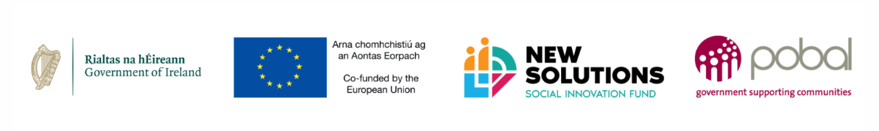
VAT NOT RECOVERABLE TEMPLATE
We are registered for Value Added Tax (VAT) with Revenue however VAT is not recoverable for this project.

To whom it may concern:
We wish to confirm that we act as auditors or accountants for (insert applicant legal name).
We confirm that (insert applicant legal name) is registered for VAT with Revenue. We also confirm that VAT is not recoverable by the (insert applicant legal name) in relation to the project activities applied for under the New Solutions Social Innovation Fund – creating better outcomes.
VAT is not recoverable for the following reason(s):
To be completed by auditor/accountant:

Signed:
Position:
Date:

